EXPERIMENT 30 – FORWARD CHAINING

AIM
To write a Prolog program to implement forward chaining.

ALGORITHM
- Start with a set of known facts.
- Define rules based on the known facts.
- Check the conditions of each rule.
- Derive new facts when the conditions are satisfied.
- Continue until the required conclusion is obtained.

PROGRAM
fact(rain).
fact(cloudy).

rule(wet_ground) :-
fact(rain).

rule(carry_umbrella) :-
fact(rain).

rule(stay_inside) :-
fact(rain),
fact(cloudy).

infer(X) :-
fact(X).

infer(X) :-
rule(X).

OUTPUT

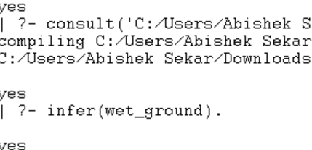

RESULT
Thus, forward chaining was successfully implemented using Prolog.

